A linked list is given such that each node contains an additional random pointer which could point to any node in the list or null.

Return a [**deep copy**](https://en.wikipedia.org/wiki/Object_copying#Deep_copy) of the list.

The Linked List is represented in the input/output as a list of n nodes. Each node is represented as a pair of [val, random_index] where:

* val: an integer representing Node.val
* random_index: the index of the node (range from 0 to n-1) where random pointer points to, or null if it does not point to any node.

**Example 1:**

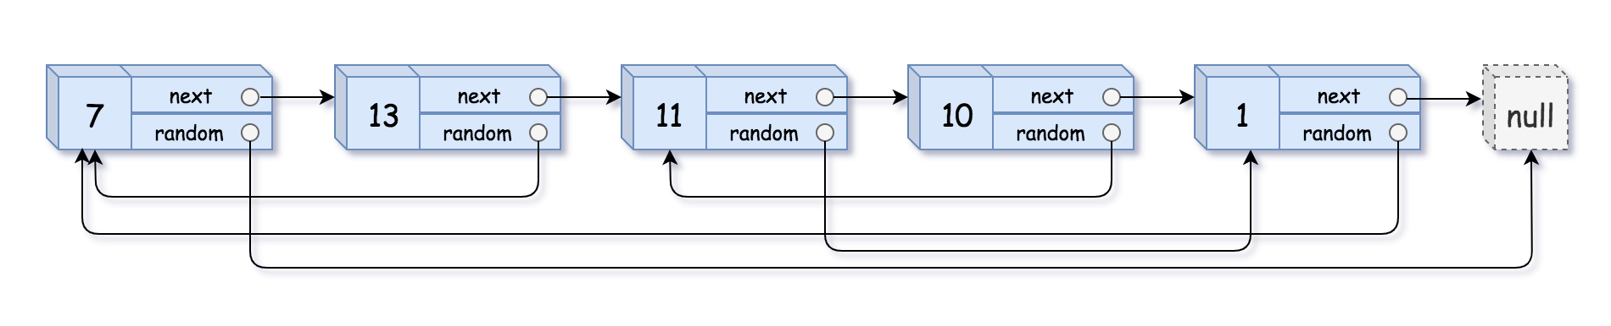

**Input:** head = [[7,null],[13,0],[11,4],[10,2],[1,0]]

**Output:** [[7,null],[13,0],[11,4],[10,2],[1,0]]

**Example 2:**



**Input:** head = [[1,1],[2,1]]

**Output:** [[1,1],[2,1]]

**Example 3:**



**Input:** head = [[3,null],[3,0],[3,null]]

**Output:** [[3,null],[3,0],[3,null]]

**Example 4:**

**Input:** head = []

**Output:** []

**Explanation:** Given linked list is empty (null pointer), so return null.

**Constraints:**

* -10000 <= Node.val <= 10000
* Node.random is null or pointing to a node in the linked list.
* The number of nodes will not exceed 1000.